**Create A Socail Media Post**

**1.Introduction**

**1.1.overview**

**Hey there, my amazing followers! I've got something awesome to share with you today. Stay tuned for a thrilling update that's going to spice up your day. Ready to dive in? #StayTuned #ExcitingNews"**

**1.2purpose**

**"Today, I'm sharing this post to inspire you all with a powerful message of resilience and determination. Let's overcome obstacles, reach for our dreams, and spread positivity together. #Inspiration #Positivity #DreamBig"**

**2.problem definition&Dsign Thinking**

**2.1 Empathy Map**

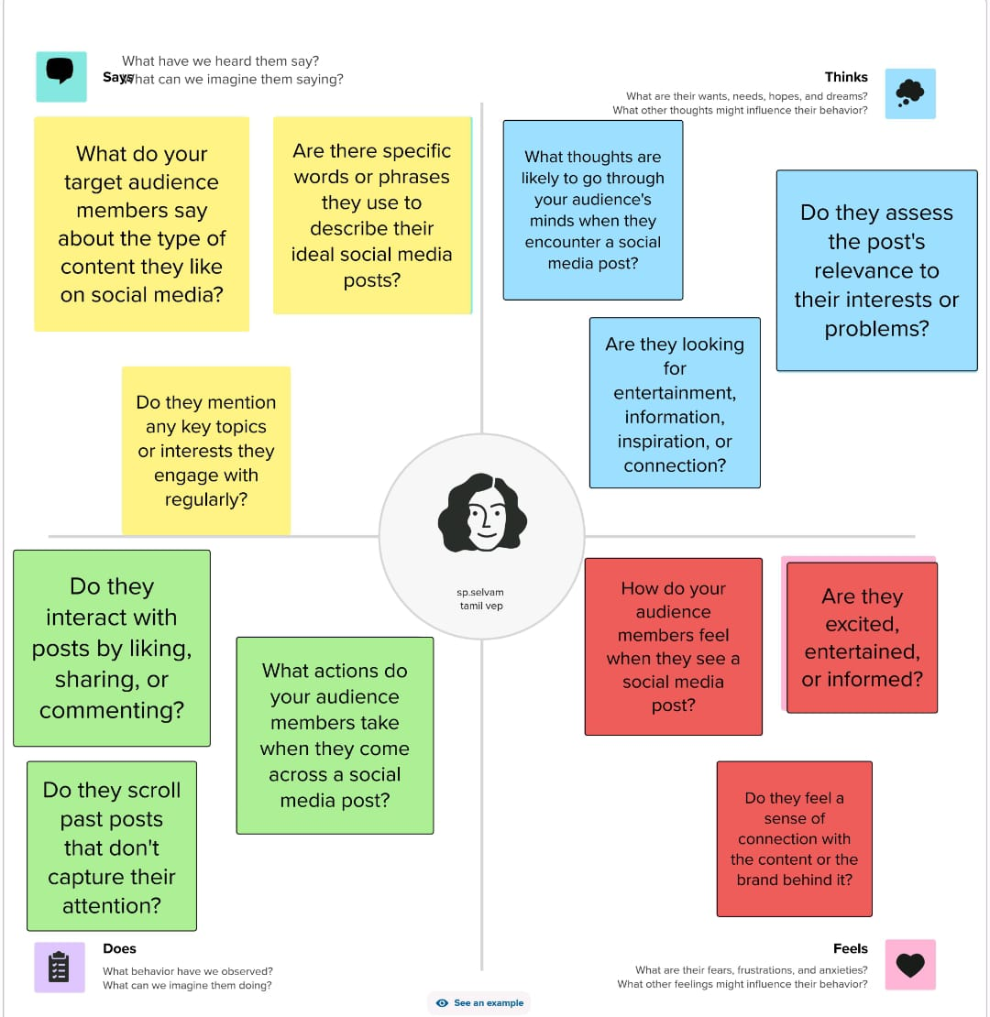

**2.2 Ideation & Brainstorming Map**

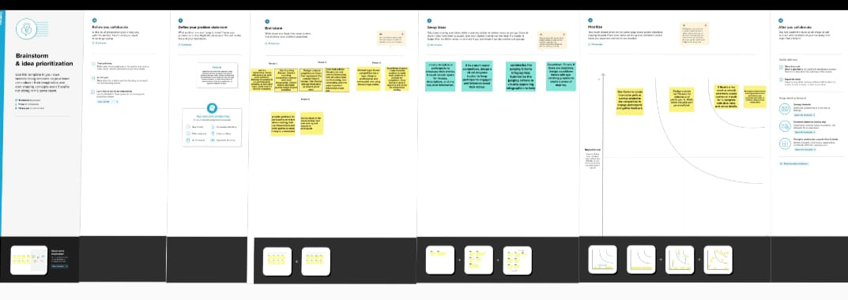

**3.Result**



**4.Advntages & Disadvantages**

**Advantages:**

**Social media allows us to connect with friends and family no matter where they are. It's a great source of news, trends, and information. A powerful tool for professional connections. A platform to express ourselves and showcase talents.**

**Disadvantages:**

**Be cautious about personal information. Can be addictive and eat up hours. A platform for negativity. People often post the best parts of their lives, which can lead to unrealistic comparisons.**

**5.Applications:**

**Today, I want to introduce you to an incredible app that's been a game-changer for me. It's called 'Productivity Pro.' This app has transformed the way I manage my tasks, stay organized, and make the most out of each day. Here are a few of its fantastic features: To-Do Lists: Easily create and manage tasks. Time Tracking: Stay on top of how you spend your time. Goal Setting: Set and track your goals efficiently. Reminders: Never forget an important task or appointment.**

**6.Conclusion:**

**Wrapping it up for today, my awesome followers! Thank you for joining me on this journey. Remember, life is a series of moments, and it's up to us to make them count. Keep smiling, stay positive, and keep chasing your dreams. Let's conquer the world together!**

**7.Future scope:**

**"The Future is Bright! As we journey through life, it's essential to keep our eyes on the horizon. The world is ever-evolving, and so are we. The future holds countless opportunities, from technological advancements to personal growth. Let's embrace change, adapt, and thrive.**

**8.Appendix:**

**For those who love to explore the details, here's an additional resource to expand your knowledge. In this appendix, you'll find extra insights, research findings, and valuable information related to our recent topic.**

**Explaination:**

